Matthew Sokolovsky

CS 361

Grammars

Due on 11/13

The work has to be done alone or in a group of 2 students.

A hard copy is required. Professional presentation is important.

100 points

Exercise 1:
We consider the BNF grammar below:
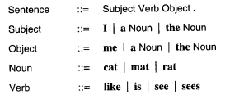
- Show that I like the cat. is recognized by this BNF grammar using a rightmost derivation and, then, a parse tree.
Sentence => Subject Verb Object . => Subject Verb the Noun . => Subject Verb the cat. => Subject like the cat. => I like the cat.

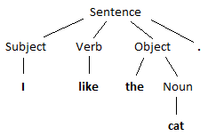

- Provide an expression that is NOT recognized by the grammar.

8

Exercise 2:

We consider the following grammar:

EXPRESSION ::= NUMERAL | ( EXPRESSION OPERATOR EXPRESSION )
NUMERAL ::= 0 | 1 | 2 | 3 | 4 | 5 | 6 | 7 | 8 | 9
OPERATOR ::= + | -

Show that (4 - (3 + 2)) is a legal EXPRESSION using a leftmost derivation, and,then, a parse tree.

EXPRESSION =>
( EXPRESSION OPERATOR EXPRESSION ) =>
( NUMERAL OPERATOR EXPRESSION ) =>
(4 OPERATOR EXPRESSION ) =>
(4 – EXPRESSION ) =>
(4 – ( EXPRESSION OPERATOR EXPRESSION )) =>
(4 – ( NUMERAL OPERATOR EXPRESSION )) =>
(4 – (3 OPERATOR EXPRESSION )) =>
(4 – (3 + EXPRESSION )) =>
(4 – (3 + NUMERAL )) =>
(4 – (3 + 2))

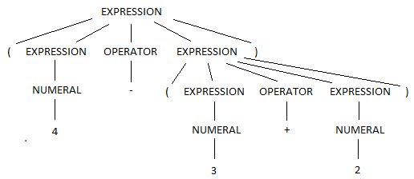

Exercise 3:

Show that the following grammar is ambiguous:

X -> a | bX | bXcX
where a,b,c are terminals.

This grammar is ambiguous because the expression bbaca has more than one possible parse tree, as shown below:

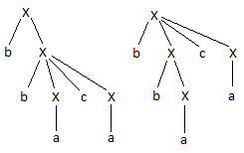

Exercise 4:

- Design a BNF grammar that recognizes expressions of the form Ai where A is in {a,b,c} and i is a digit.

Ex -> Ai
A -> a | b | c
i -> 0 | 1 | 2 | 3 | 4 | 5 | 6 | 7 | 8 | 9

- Design a BNF grammar that recognizes lists of the form A1, A2, A3, …, An. Use question a).

List -> Ex | Ex, List
Ex - > Ai | …
I -> 0 | 1 | 2 | 3 | 4 | 5 | 6 | 7 | 8 | 9 | n

Exercise 5:

- Write a JAY program that computes the sum of the n first numbers with a loop.

int sum (int n) {
int a;
a = 0;
while (n > 0) {
a = a + n;
n = n – 1;
}
return a;
}

- Write a JAY program that assigns the minimum of two numbers in a variable called min.

void main () {
int a, b, min;
a = 5;
b = 6;
if (a < b) {
min = a;
}
else {
min = b;
}
}

- Provide 2 examples of lexical errors in JAY.

$

&=

- Provide 2 examples of JAY programs with 2 different syntax errors.

void main () {
int x =
}

void main {
int x;
}

- Provide 2 examples of JAY programs with errors that are neither detected during the lexical analysis nor during the syntactic analysis.

void main () {
int x;
x = 6 / 0;
}

void main () {
int x;
x = a;
}

